No.15, autumn, 2014
 
❖                                         
Dear colleagues!
The Non-profit organization Tomsk English Language Teachers
Association greets you on our Fifteenth Annual Conference!


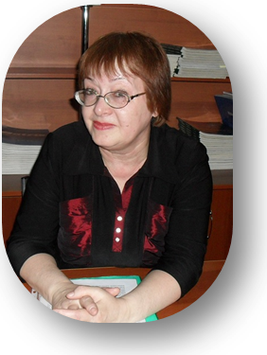

 Our congratulations to Zimfira Aptineeva
the winner of the contest
‘The Best Teachers of the Russian Federation’


TomELTA Events
* * * * * * * * * * * * * * * * * * * * * * * * * * * * * * * * * * * * * * * * * * * *

Contest “Meet America 11 class”
Contest “Meet Great Britain 10 class”
Contest “Linguistic Battle 6 class”
Information about the contests: see on http://tomelta.jimdo.com

English + IT contest 18.10.14 school #40
Pedagogical University Annual Conference in January

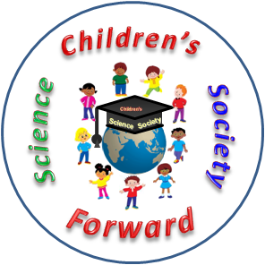
Children’s Science Society "Forward" club working
Children’s Science Society "Forward", meeting on 29.11.14
Speakers' Tournament "It's fashionable to be healthy"
Conference "Science in my life". April, school #40, All teams are welcomed!
Information about CSS events see on http://dnoforward.jimdo.com

"The Seventh Tournament of Debates" in December - school #40.
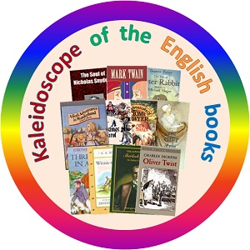

Contest "Kaleidoscope of the English books" in March

Information about the contests and events see on http://tomelta.jimdo.com

Good Luck!

Edited by Tatyana Konovalova

